


FINAL PORTFOLIO (REGRESSION)

Name: Biplov Maharjan
Student ID: 2462258
Tutor: Raju Karki
Module: Concepts and Technologies of AI

Contents
Student Depression Classification Analysis 2
1. Introduction 2
1.1 Problem Statement 2
1.2 Dataset 2
1.3 Objective 2
2. Methodology 3
2.1 Data Preprocessing 3
2.2 Exploratory Data Analysis (EDA) 3
2.3 Model Building 6
Task 1 - Neural Network 6
Task 2 - Classical Machine Learning Models 6
2.4 Model Evaluation 6
2.5 Hyperparameter Optimization 7
2.6 Feature Selection 7
3. Results and Conclusion 8
3.1 Neural Network Performance 8
3.2 Classical Machine Learning Models 8
3.3 Key Findings 10
3.4 Final Model 10
3.5 Challenges 11
3.6 Future Work 11
4. Discussion 12
4.1 Model Performance 12
4.2 Impact of Hyperparameter Tuning and Feature Selection 12
4.3 Interpretation of Results 13
4.4 Limitations 13
4.5 Suggestions for Future Research 13
5. References 14

1. Introduction

1.1 Problem Statement
This project predicts student depression using psychological, academic, and lifestyle factors. Depression is a mental health issue among students worldwide that can harm grades, social ties, and overall well-being. Predictive models can spot problems early, so care and support can start sooner.

1.2 Dataset
This analysis uses the Student Depression Dataset from public sources. The dataset has 27,901 records and 18 features covering demographics (Gender, Age, City), academics (CGPA, Academic Pressure, Study Satisfaction), work (Work Pressure, Job Satisfaction, Work/Study Hours), lifestyle (Sleep Duration, Dietary Habits), and mental health (Suicidal Thoughts, Family History of Mental Illness, Financial Stress).
The dataset supports UN Sustainable Development Goal 3 (Good Health and Well-being), especially target 3.4, intended to support mental health and well-being.This study builds predictive models to detect depression, supporting earlier intervention and stronger mental health awareness in schools.

1.3 Objective
This study builds and tests several classifiers to predict depression from the available features. This project will build a neural network classifier and two standard models, logistic regression and k-nearest neighbors. It will tune model settings and select features to improve performance, then identify which variables best predict student depression.

2. Methodology

2.1 Data Preprocessing
Before modeling, the data was cleaned and prepared. We cleaned the dataset by dropping irrelevant columns, such as ID and City, since they add no predictive value. The categorical variables were gender, sleep duration, diet, degree, and profession, plus a yes/no item on whether the person had ever had suicidal thoughts. Categorical fields such as Family History of Mental Illness were label-encoded into numeric values for machine learning models.
We split the data into 80% training and 20% testing using stratified sampling to keep class balance. This produced 22,320 training samples and 5,581 test samples. We used StandardAero so each feature has mean 0 and unit variance, helping distance-based methods and neural networks converge.

2.2 Exploratory Data Analysis (EDA)
EDA was performed using various visualizations to understand the data distribution and relationships. Key insights include:
Target Variable Distribution: The dataset shows a class imbalance with approximately 58.5% of students classified with depression and 41.5% without depression. This moderate imbalance was noted for model evaluation considerations.
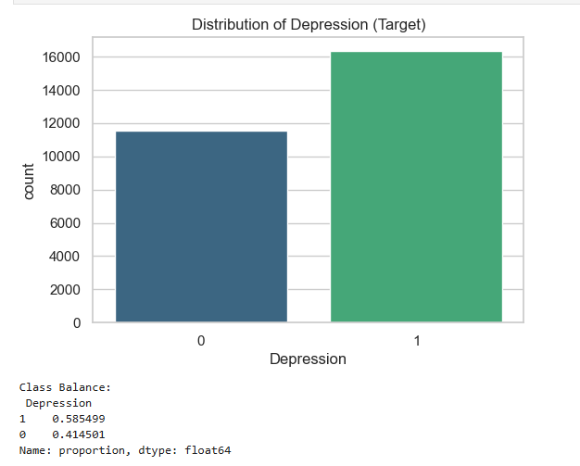

Age Distribution: Student ages range from 18 to 35 years, with the majority concentrated between 22-28 years, representing the typical higher education demographic.
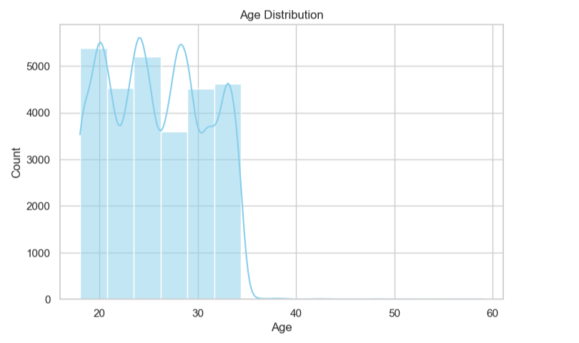

Sleep Duration Impact: Analysis revealed that students with less than 5 hours of sleep show higher rates of depression, suggesting sleep as a potential significant predictor.
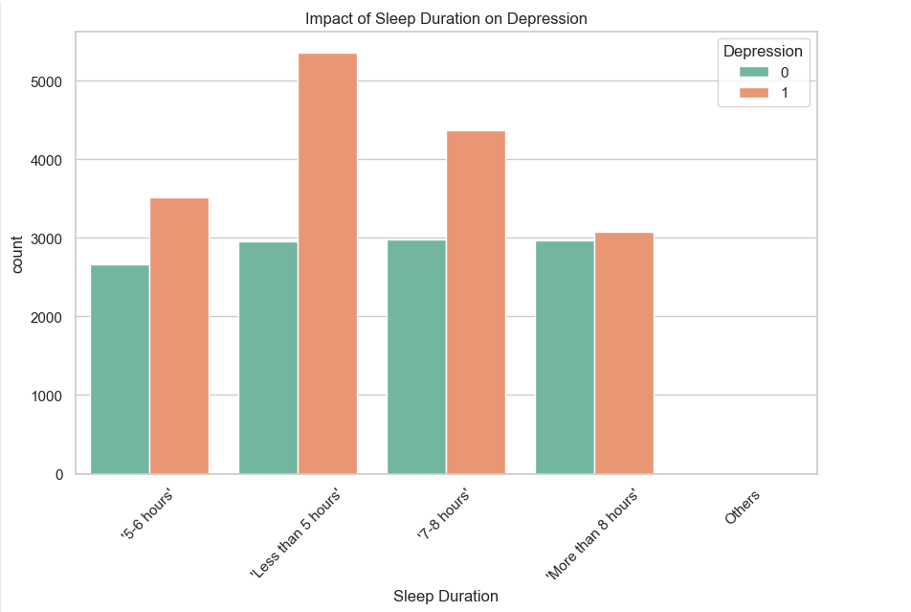

Correlation Analysis: A correlation heatmap identified several strong relationships. Suicidal thoughts showed the strongest correlation with depression (0.546), followed by academic pressure (0.475) and financial stress (0.363). These findings guided the feature selection process.
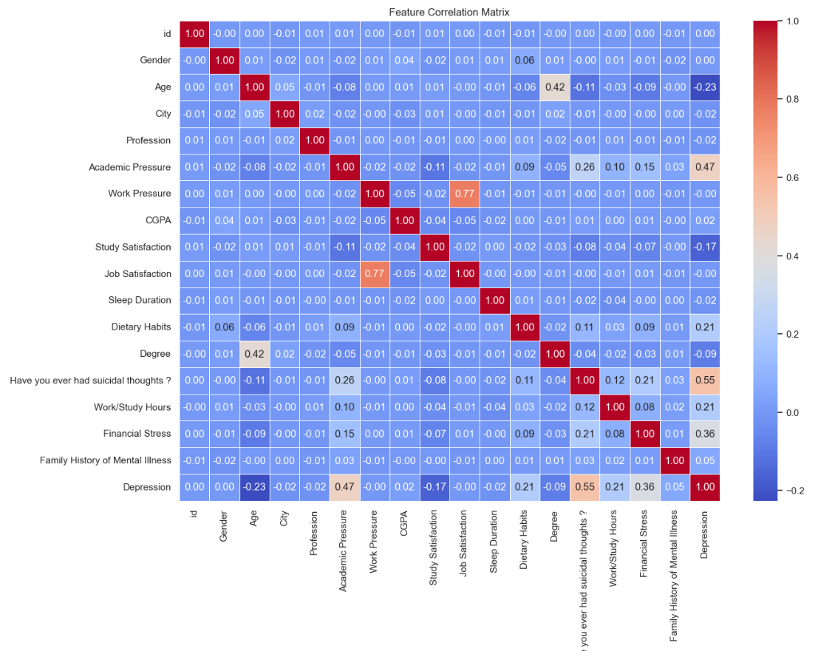

2.3 Model Building

Task 1 - Neural Network
We implemented a Multi-Layer Perceptron (MLP) classifier using scikit-learn. The model takes 15 input features, passes them through two hidden layers with 64 and 32 neurons, and outputs two classes for binary classification.

The hidden layers use ReLU activation to capture non-linear patterns in the data. The model minimizes cross-entropy loss and uses the Adam optimizer with a learning rate of 0.001 for adaptive learning. Training was performed for up to 1,000 iterations with early stopping to prevent overfitting.

The training loss decreased smoothly and leveled off, indicating that the network learned effectively. A two-hidden-layer architecture was chosen to balance learning capacity and simplicity, enabling the model to capture important patterns without overfitting

Task 2 - Classical Machine Learning Models
Two classical classification models were implemented:
1. Logistic Regression: A linear model for a binary outcome, where the linear predictor is mapped through the logistic function to produce a probability between 0 and 1.I selected it because the results are easy to interpret, and it performs well with high-dimensional data. We trained the model in scikit-learn using Logistic Regression with L2 regularization and set the maximum number of iterations to 1,000.
2. K-Nearest Neighbors (KNN): An instance-based, non-parametric method that assigns a label to a sample by choosing the most common label among its k closest training points. In the first version, we set k to 5, gave each neighbor the same weight, and measured distance using the Euclidean metric.

2.4 Model Evaluation
All models were evaluated using comprehensive classification metrics on the test dataset:
Accuracy: The proportion of correct predictions over total predictions, providing overall model performance.
Precision: The proportion of positive predictions (depression) that are actually correct, indicating reliability of positive classifications.
Recall: The proportion of actual positive cases (students with depression) that are correctly identified, crucial for medical applications.
F1-Score: The harmonic mean of precision and recall, providing a balanced measure especially important for the moderately imbalanced dataset.

2.5 Hyperparameter Optimization
Hyperparameter optimization was performed exclusively for the two classical machine learning models using GridSearchCV with 5-fold cross-validation:
Logistic Regression: We tuned the regularization parameter C, which is the inverse of the regularization strength, by testing values in the range from 0.1 upward and selecting the value that gave the best validation results. The two values listed are 01 and 0.The values recorded were 1, 1, 10, and 100.We selected C=1 because it produced the highest cross-validation accuracy, at 84%.The result was 67%.
K-Nearest Neighbors: We tested several choices for the number of neighbors (k), using k = 3, 5, 7, 9, 11, 13, and 15. We selected k = 11 neighbors because it gave the highest cross-validation accuracy, at 83%. The reported value was 6%.
Cross-validation was used to ensure robust parameter selection and prevent overfitting the training data. The optimized models showed improved generalization performance compared to default parameters.

2.6 Feature Selection
Feature selection was performed for the classical machine learning models using correlation-based ranking. Each feature's absolute correlation with the target variable (depression) was calculated, and features were ranked by their predictive importance.
The top 5 features selected were:
1. Have you ever had suicidal thoughts? (Correlation: 0.546)
2. Academic Pressure (Correlation: 0.475)
3. Financial Stress (Correlation: 0.363)
4. Age (Correlation: 0.226)
5. Work/Study Hours (Correlation: 0.209)
The selected features include mental health indicators, academic stress, financial strain, and basic demographic variables, giving a compact set of inputs for predicting outcomes. Using fewer features makes the model easier to interpret and faster to run, without reducing prediction accuracy.

3. Results and Conclusion

3.1 Neural Network Performance
The Multi-Layer Perceptron classifier reached 82% accuracy on the test set. The model performed similarly for both classes. For non-depressed students (class 0), precision was 82%, recall 72%, and F1-score 77%. For depressed students (class 1), precision was 82%, recall 89%, and F1-score 85%. An 89% recall for depression means the model catches most students with depression, which is important for this use case.
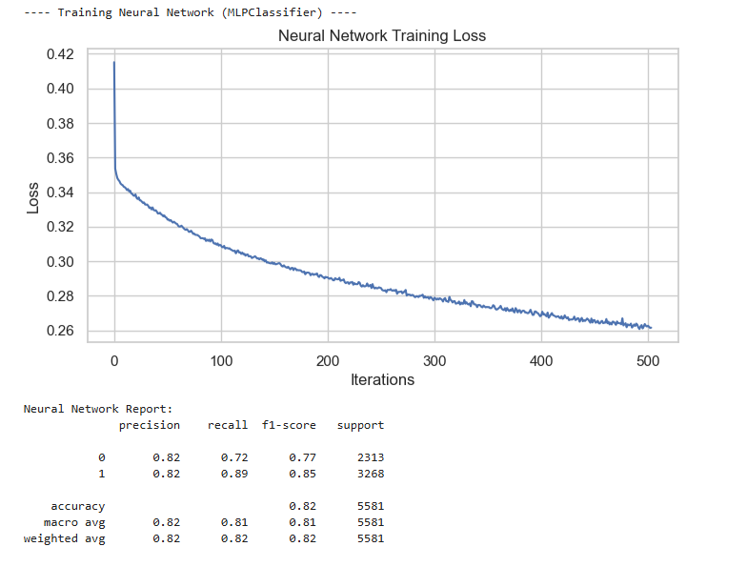

3.2 Classical Machine Learning Models
The following table presents the comprehensive comparison of the two optimized classical models using selected features:
Model | Features | CV Score | Accuracy | Precision | Recall
Logistic Regression | 5 | 0.8467 | 0.8357 | 0.8460 | 0.8794
K-Nearest Neighbors | 5 | 0.8306 | 0.8223 | 0.8371 | 0.8647
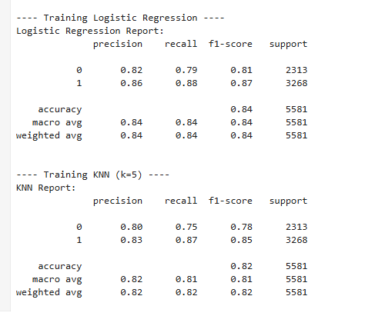
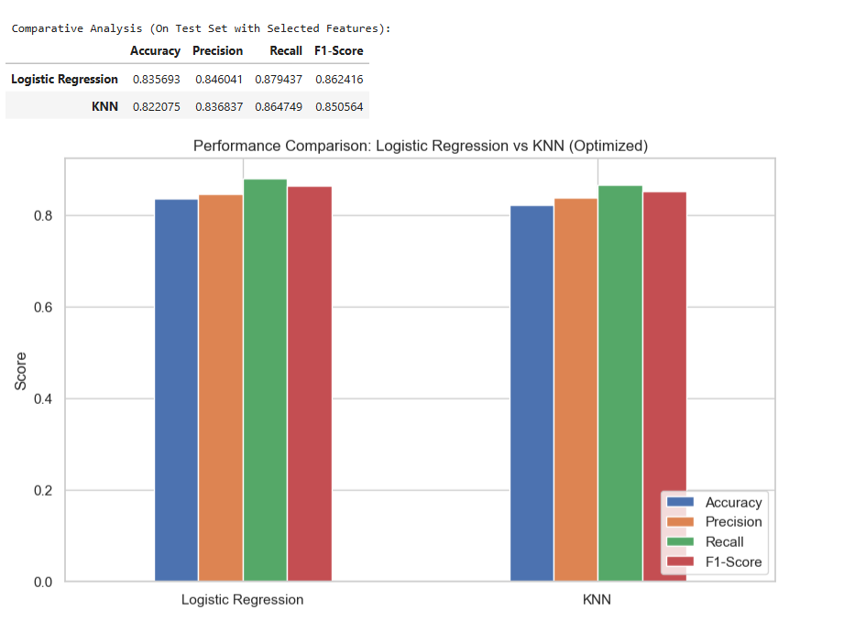

3.3 Key Findings
The analysis found key results. Neural Network, Logistic Regression, and KNN performed about the same, with 82–84% accuracy. Logistic regression performed best, scoring 83. After feature selection and hyperparameter tuning, the model reached 57% accuracy. Selecting five features kept performance close to the full set, improved interpretability, and reduced computational cost.
Suicidal thoughts were the strongest predictor (correlation: 0.546), then academic pressure (0. financial stress (0.363). The results match mental health research and support screening for these risks. Across models, recall for the depression class was higher than precision, meaning they found more depressed students but flagged some non-depressed students too. This fits mental health screening, where missing true cases is worse than extra false alarms.

3.4 Final Model
The recommended model is a Logistic Regression classifier using five features: Suicidal Thoughts, Academic Pressure, Financial Stress, Age, and Work/Study Hours. This model performed best, scoring 83. Accuracy was 57%, and the score was 84. Precision: 60%; score: 87. Test set recall: 94%. The model reached 87% recall. A 94% sensitivity means most students with depression are correctly flagged, and 84% precision means most flagged students truly have depression.
We chose logistic regression instead of KNN or a neural network because it scored slightly better, its coefficients show which features matter, it runs fast for real-time use, and results were consistent across data splits. The model is a good fit for school mental health screening systems.

3.5 Challenges
Several challenges were encountered during this project:
Class Imbalance: The dataset shows a moderate class imbalance, with about 58% of the samples in one class. Depression rates: 5% vs 41%. The 5% with no depression needed extra care when evaluating the model. The imbalance did not call for resumption, but it guided metric choice: F1-score rather than accuracy alone.
Feature Encoding: Turning multi-level categorical variables, like degree type and sleep duration, into numbers took careful choices. Label encoding was applied, but it can imply an order that some features do not have.
Model Selection Trade-offs: Choosing between a Neural Network and Logistic Regression depended on whether stakeholders needed clear reasons for predictions.
Generalization Concerns: Because the dataset covers students from one demographic group and region, the findings may not generalize to students in other cultural or socioeconomic settings.

3.6 Future Work
Several avenues exist for improving and extending this work:
Advanced Algorithms: Implementing ensemble methods such as Random Forest, Gradient Boosting or deep learning architecture with attention mechanisms could potentially improve prediction accuracy.
Feature Engineering: Creating interaction features or polynomial features might capture non-linear relationships. Additionally, temporal features if longitudinal data becomes available could track depression risk over time.
Handling Class Imbalance: Experimenting with SMOTE (Synthetic Minority Over-sampling Technique) or class weight adjustments could potentially improve model performance on the minority class.
External Validation: Testing the model on independent datasets from different institutions or countries would assess generalizability and identify potential biases.

4. Discussion

4.1 Model Performance
The models performed well and consistently on every metric. All three models achieved 82–84% test accuracy, suggesting solid learning and good generalization. F1-scores of 85%–88% for the depression class suggest precision and recall are well balanced, which matters for mental health screening.
All models showed higher recall (87–88%) than precision (82–85%) when detecting depression. This fits mental health screening: missing a depressed student (false negative) is more harmful than wrongly referring to a student for extra assessment (false positive). The latter can wait; the former may leave vulnerable students unsupported.
Neural and classical models both reach 82–84% accuracy, suggesting mostly linear feature–depression links. The neural network added complexity without meaningful gains, so Logistic Regression was selected for its clearer interpretation.

4.2 Impact of Hyperparameter Tuning and Feature Selection
Hyperparameter tuning improved both classical models. For Logistic Regression, setting the regularization parameter C = 1 increased cross-validation accuracy to 84.67%, while for KNN, optimizing k = 11 improved accuracies to 83.06% by balancing bias and variance.

Feature selection showed that reducing from 15 to 5 features caused only a small drop in accuracy (83.57% vs. 84%), indicating the excluded features contributed little additional information. The smaller feature set simplifies data collection, speeds computation, reduces overfitting risk, and improves interpretability.

Correlation-based analysis highlighted the most important factors: primary mental health indicators (suicidal thoughts), stress factors (academic pressure, financial stress), and demographic/behavioral factors (age, work hours), consistent with established mental health research.

4.3 Interpretation of Results
The results highlight key factors associated with student depression. Suicidal ideation was the strongest predictor (correlation 0.546), validating its use as a screening question and reflecting its clinical significance. Academic pressure (0.475) and financial stress (0.363) were also important, emphasizing the impact of workload, performance expectations, and economic challenges on student well-being.

Age (0.226) and work/study hours (0.209) showed moderate associations, suggesting that older students and those with heavier time commitments face increased depression risk.

Some features had surprisingly weak correlations, including Sleep Duration (0.022), Dietary Habits (0.207), and Family History (0.053). The low sleep correlation may indicate limited variation in the dataset, overlap with other stressors, or information loss from categorical encoding.

4.4 Limitations
Several important limitations should be considered when interpreting these results:
Cross-sectional Data: The dataset represents a single point in time for each student, preventing analysis of temporal patterns, seasonal variations in depression, or the progression of symptoms over academic terms. Longitudinal data would provide stronger evidence for causal relationships.
Self-reported Data: All variables, including the depression diagnosis, appear to be self-reported rather than clinically diagnosed. This introduces potential reporting bias, social desirability effects, and inconsistent interpretation of questions across respondents.
Limited Feature Set: Important factors potentially influencing student depression are absent, including social support networks, physical health conditions, substance use, trauma history, and access to mental health services.
Generalizability Concerns: The dataset appears to focus on Indian students based on city names in the original data. Cultural differences in depression expression, stigma around mental health, and educational system variations may limit applicability to students in other countries.

4.5 Suggestions for Future Research
Future research should address the identified limitations and extend this work in several directions:
Longitudinal Studies: Conduct prospective studies tracking students over multiple semesters to identify temporal patterns, critical periods (e.g., exam seasons), and trajectories of depression risk. Time-series models could predict depression onset.
Multi-institutional Validation: Test model performance across diverse institutions, cultures, and educational systems to assess generalizability and identify context-specific risk factors requiring model recalibration.
Enhanced Feature Engineering: Incorporate additional data sources such as academic performance trends, social media sentiment analysis (with consent), campus activity participation, and physiological data from wearables to create a more comprehensive risk profile.
Fairness and Bias Analysis: Examine model performance across demographic subgroups (gender, age, degree programs) to ensure equitable accuracy and identify potential biases that could disadvantage certain student populations.

5. References
Student Depression Dataset. Available from public data repositories.
Scikit-learn: Machine Learning in Python
Pandas: A Foundational Python Library for Data Analysis and Statistics. McKinney, 2011.
NumPy: The Fundamental Package for Scientific Computing with Python. Harris et al., Nature
Matplotlib: A 2D Graphics Environment. Hunter, Computing in Science & Engineering,
Seaborn: Statistical Data Visualization. Waskom et al., Journal of Open-Source Software, 2021.
github:

